EWEA 2013: B&R brings your visions to life
Reducing costs with innovative automation solutions

In Hall B, Booth H20 at the EWEA 2013 from February 4–7, 2013 in Vienna, B&R will be demonstrating how innovative automation solutions can significantly contribute to cost reductions. Optimizing mechanical components through the use of intelligent safety solutions is one way to considerably increase operational safety across the board. As a leader in integrated safety technology, B&R will be demonstrating how the new safety requirements for certification of wind power systems in the GL 2010 guideline can be implemented in an extremely efficient and economical manner.

openSAFETY: Safety technology declares its independence
The safety system is based on the open, fieldbus-independent safety standard openSAFETY and can be seamlessly integrated with all standard controllers. In addition to digital I/O, it also provides analog or temperature interfaces as well as safe speed measurement up to SIL3 and performance level e.

X20 control systems: The first choice for offshore wind parks
An additional trade fair highlight on display will be the highly successful X20 control system. Because the system is highly robust, it is the perfect solution for mastering the extreme conditions associated with offshore wind power systems. Modular redundancy solutions – e.g. for the main controller, the safety system and the real-time Ethernet POWERLINK fieldbus – maximize the availability of the system, making time-consuming and costly application re-engineering a thing of the past. In addition, B&R's intelligent condition monitoring solution is easy to use and makes it possible to coordinate maintenance more effectively to avoid system downtime.

APROL process control systems – The best solution for wind power systems
The scalable APROL process control system allows efficient manufacturer-independent management of entire wind parks – from just a few systems all the way up to large parks that include many thousands of systems with an additional higher level hierarchy. Integrated data management, reporting with unlimited configuration possibilities and Audit Trail – for certified logging of all interactions – are included as standard features. Several algorithms for things like park power management can also be easily implemented and executed on the process control system.

B&R systems for future proofing wind power systems
Code generation for MATLAB/Simulink makes it possible to transfer sophisticated control algorithms to B&R systems that maximize energy yield while minimizing the load on machine components with a simple click of the mouse. This is but one way of meeting the challenges presented by wind turbines, a crucial technology as we move into the future. At the 2013 EWEA trade fair, B&R expert automation solution specialists will once again be placing the focus squarely where it belongs – on quality, availability and overall safety.

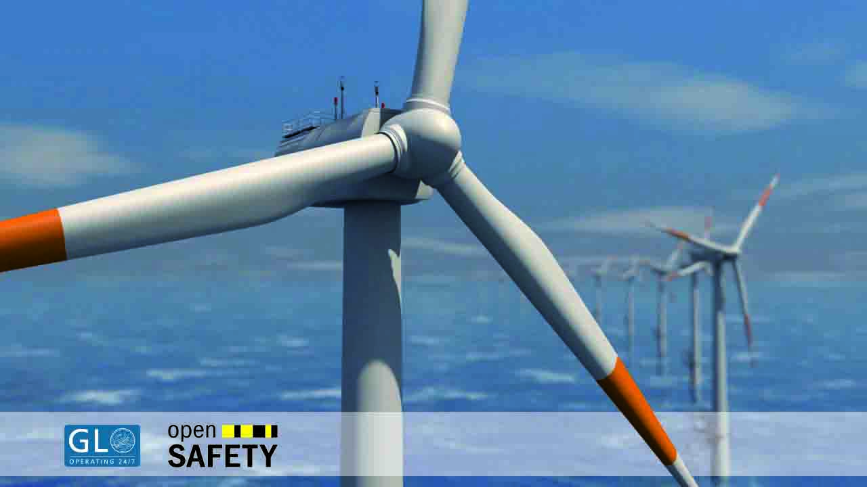 | Image: IE32802_4c.jpg  Caption: B&R will be demonstrating how the new safety requirements for certification of wind power systems in the GL 2010 guideline can be implemented in an extremely efficient and economical manner.  High-resolution version of this image attached.

Words | 426
Characters without spaces | 2,426
Characters with spaces | 2,849
Image(s) | 1

About B&R:

B&R is a privately owned company with headquarters in Austria and offices all around the world. As a global leader in industrial automation, B&R combines state-of-the-art technology with advanced engineering to provide customers in virtually every industry with complete solutions for machine and process automation, motion control, HMI and integrated safety technology. With industrial fieldbus communication standards like POWERLINK and openSAFETY as well as the powerful Automation Studio software development environment, B&R is constantly redefining the future of automation engineering. The innovative spirit that keeps B&R at the forefront of industrial automation is driven by a commitment to simplifying processes and exceeding customer expectations.

For more information, please visit www.br-automation.com.

When reprinting this press release, please send a copy to:
Bernecker + Rainer Industrie-Elektronik Ges.m.b.H., Corporate Communications
B&R Strasse 1, A-5142 Eggelsberg

