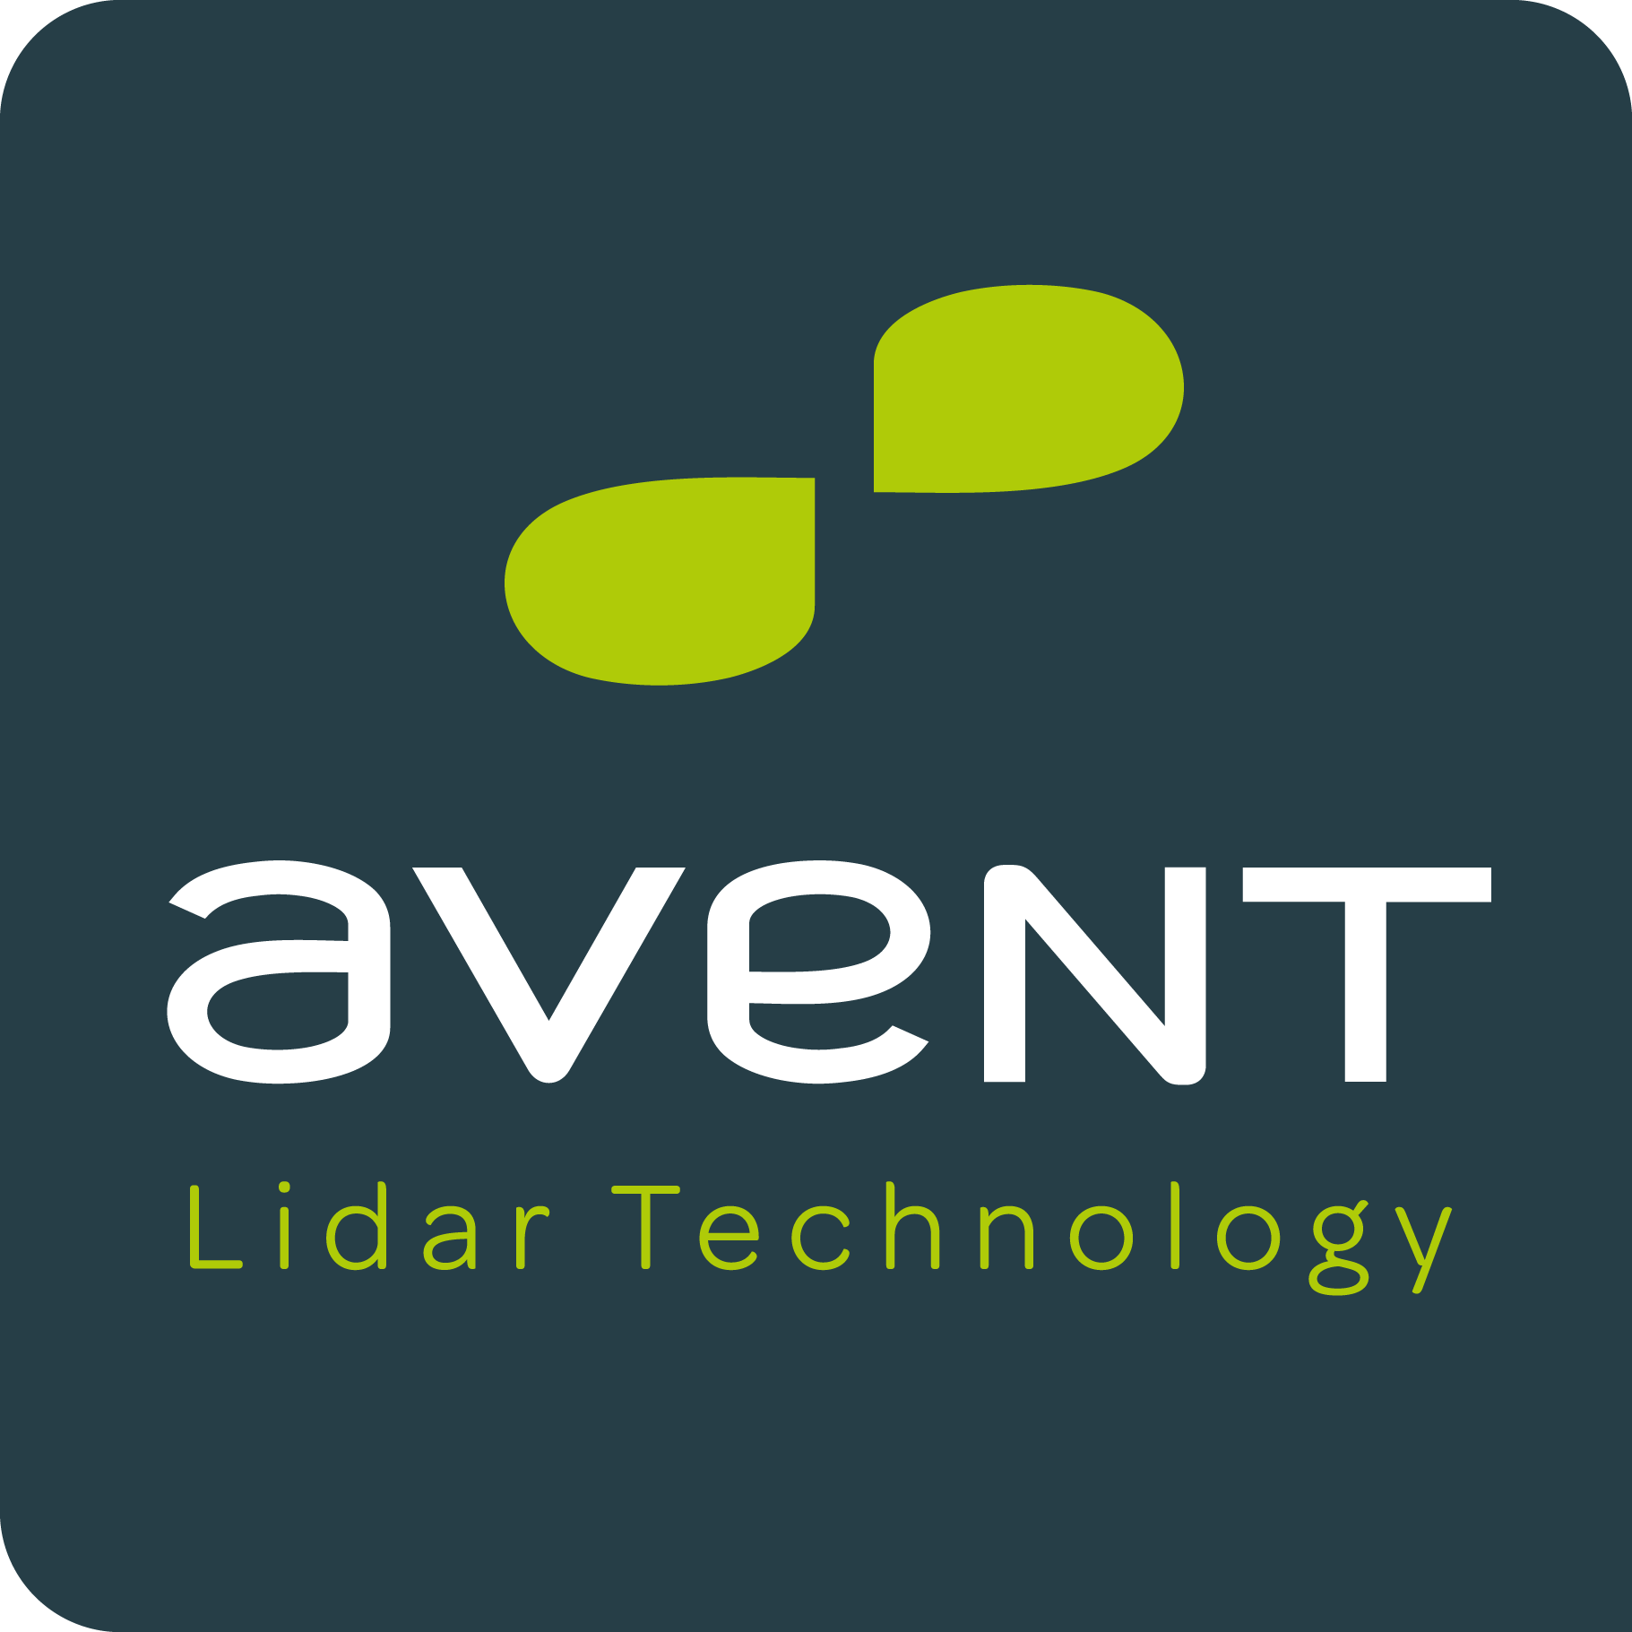

JOB OFFER
International business developer M/W
Réf : 2013AVT04

Posted : 30/01/2013
Contact :
vtamboise@leosphere.fr

Valentine TAMBOISE
Leosphere SAS
14/16 rue Jean Rostand
91400 Orsay
www.leosphere.com

CONTEXT
- High Tech SME of 25 employees
- Joint venture between Leosphere, the European specialist of atmospheric measure by LIDAR (Orsay, France) and NRG Systems, the international leader of wind measure in wind energy (Vermont, USA)
- Emerging market of wind industry (BtoB)
- A growing SME (turnover*4 in 2012)
- International clients (Europe, North America, Asia), + 90% of turnover achieved abroad

JOB DETAILS
Location: Orsay (91)
Job type: Permanent
RESPONSIBILITIES
AVENT is looking for an International business developer. You will be joining the Marketing and sales team and will be in charge of the hightech systems sales and the development of clients portfolio.
You will be involved in operational marketing tasks.
Business development :
- Contribute to prospection
- Be in charge of the entire sale process (offers, negotiations, closing)
- Detect and develop client accounts
- Monitor and report sales
- Develop the international distribution network
- Participate to international events and conferences

Marketing :
- Contribute to competitive and market intelligence
- Act as a support for Marketing division

Required Skills
- Business degree
- 3 to 5 years of experience in an industrial and international sales environment.
- Excellent working knowledge of technologic, industrial and scientific markets
- Strong understanding of the sale process
- Experience in developing client account
- Fluency in English and knowledge of any other language

Qualities

- Communication
- Skills in negociation
- Client minded approach, outstanding sense of business, relational intelligence
- Dynamism
- Autonomy, initiative
- Flexibility to adapt to a SME

